**Question2:**

**Create a Python script: in**

**Tested it in VS code and I got the required output**

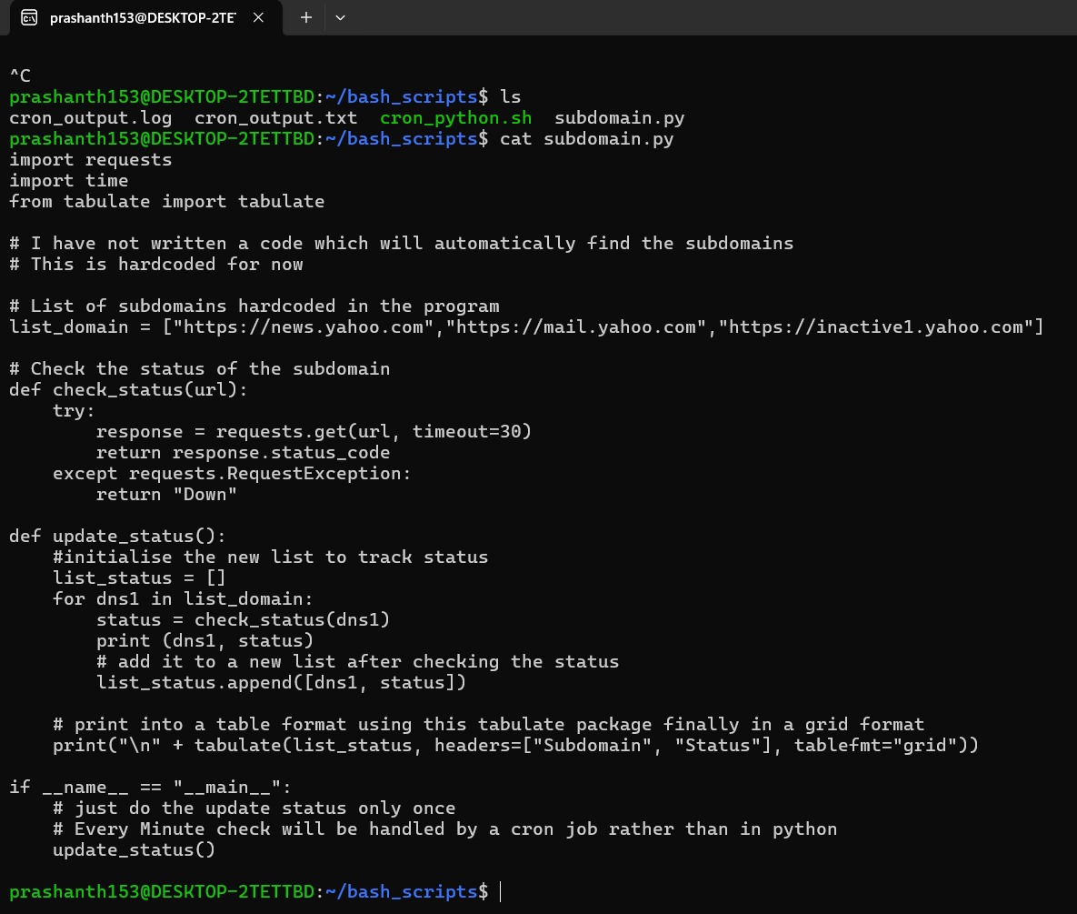

**When I try to run the script stand alone in Ubuntu it works perfectly fine**

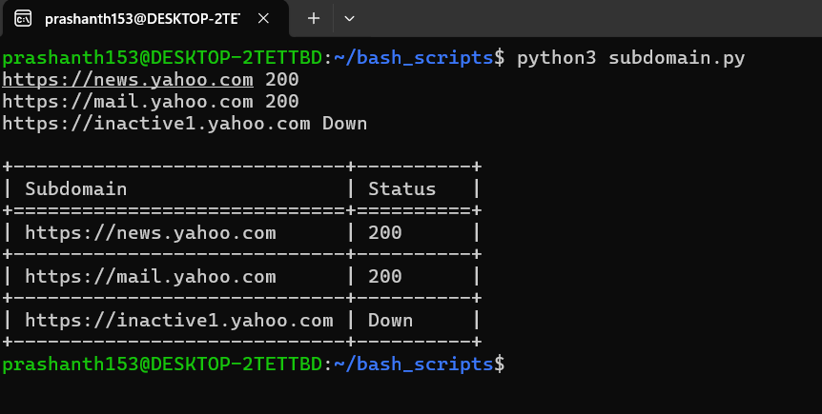

**Created a bash script to execute using a cron job**

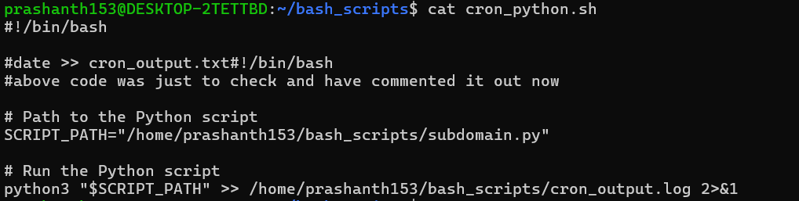

**Please note Iam writing the output to a cron_output.log file**

**I had to edit the .profile path to add the required file and change the permission of bash script to 744**

**When I execute echo $PATH, I can see the bash_scripts folder added in the path**



**Cron Job setup**

**This job will run every minute as stated in the problem statement and write into the log file.**

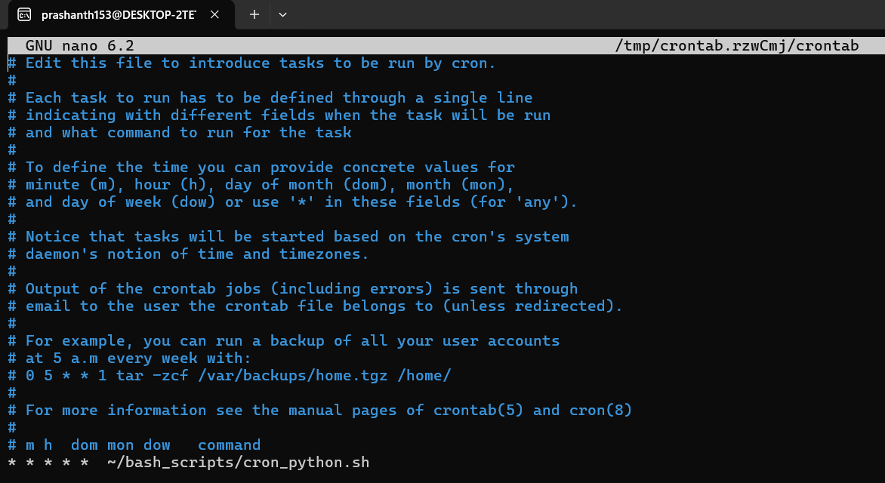

**Cron Log Output:**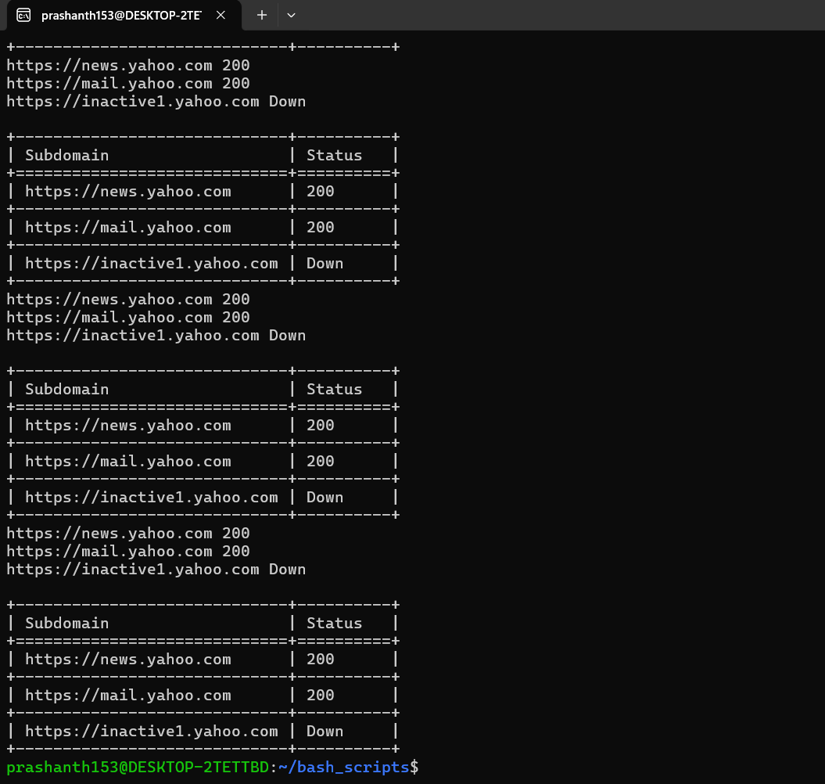

**Tail -f command will show the required output**

